EXP 2: BOOK BANK REGISTRATION SYSTEM

1.USE CASE DIAGRAM:
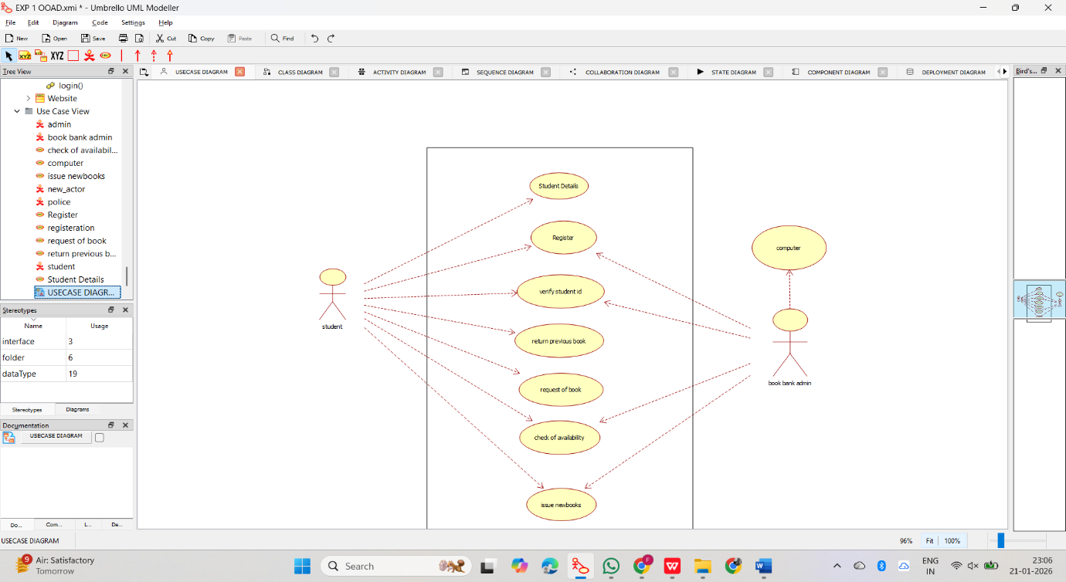

2.CLASS DIAGRAM:
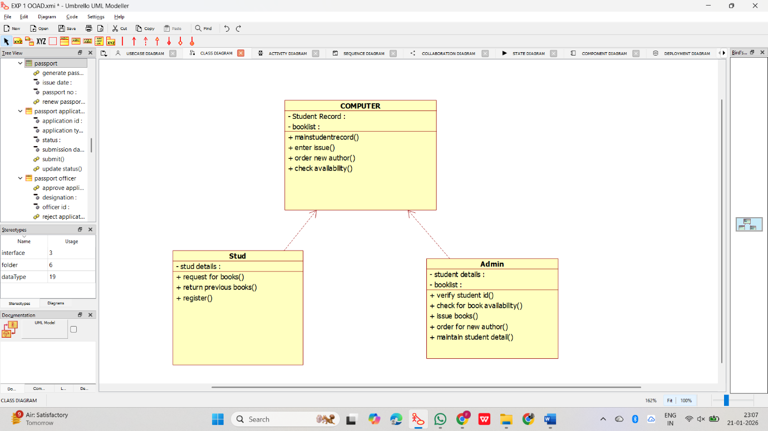

3.ACTIVITY DIAGRAM:
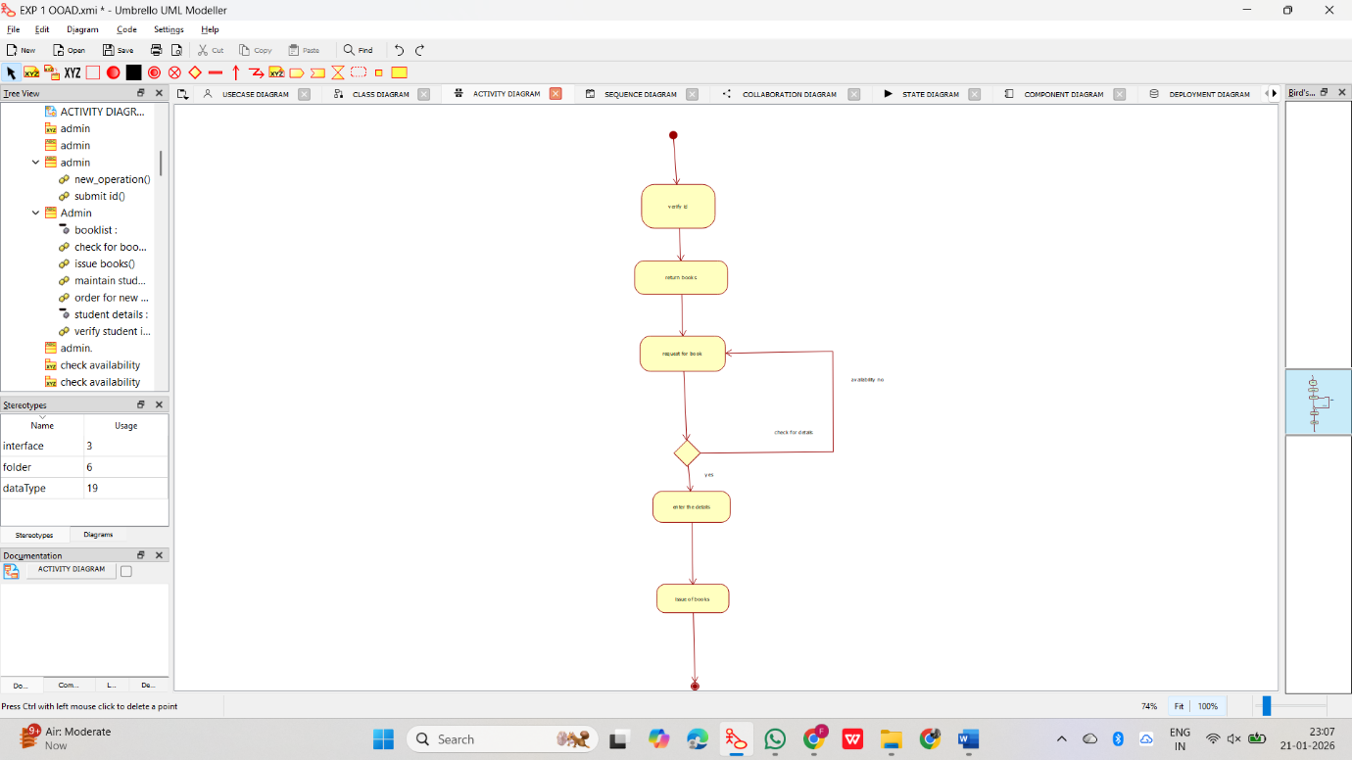

4.SEQUENCE DIAGRAM:
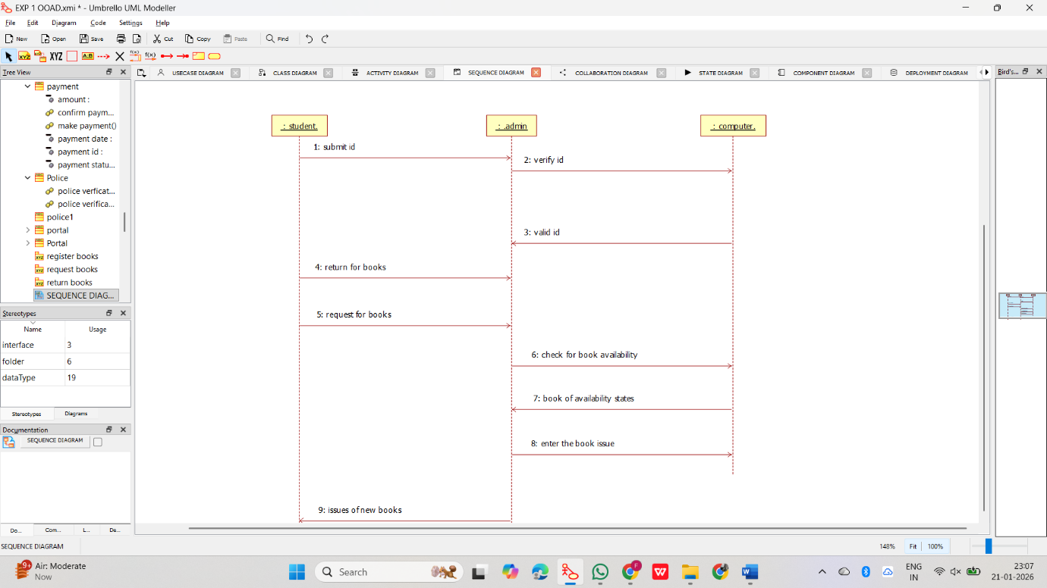

5.COLLABORATION DIAGRAM:
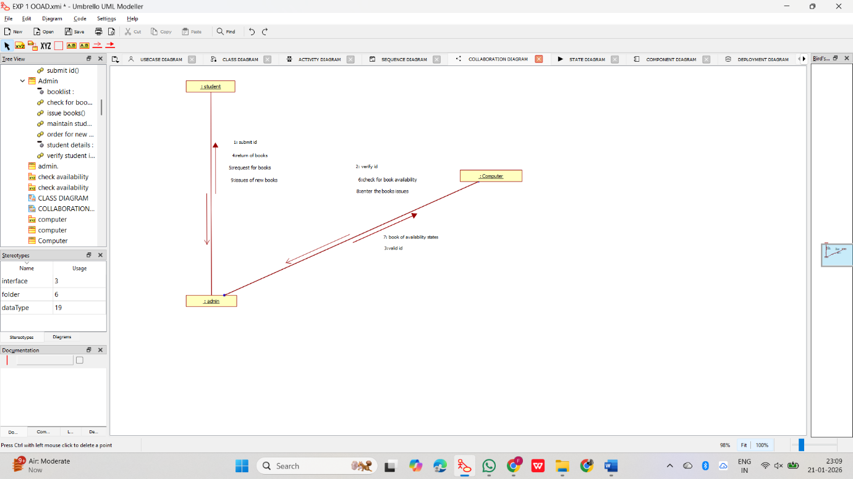

6.STATE CHART DIAGRAM:
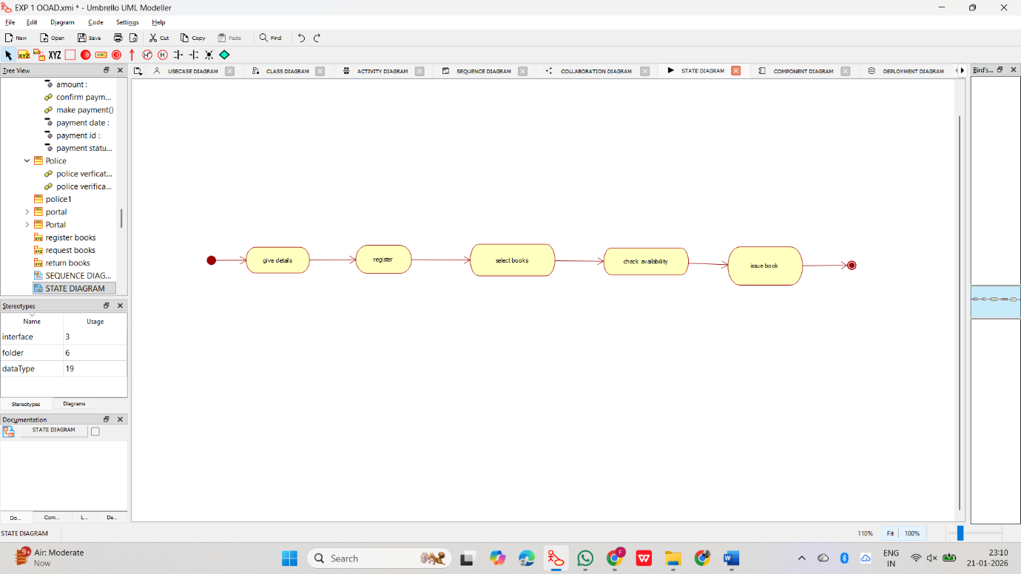

7.COMPONENT DIAGRAM:

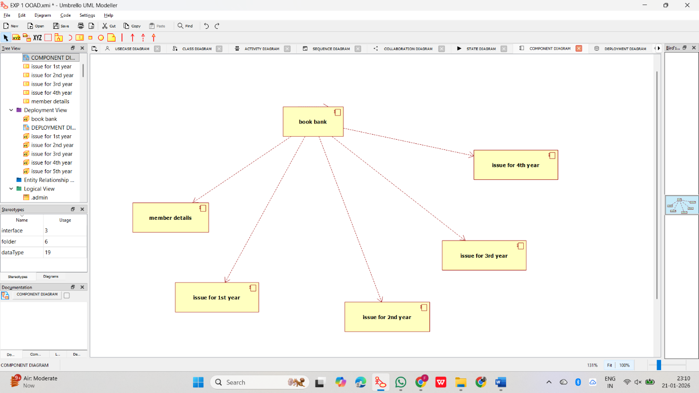

8.DEPLOYMENT DIAGRAM:

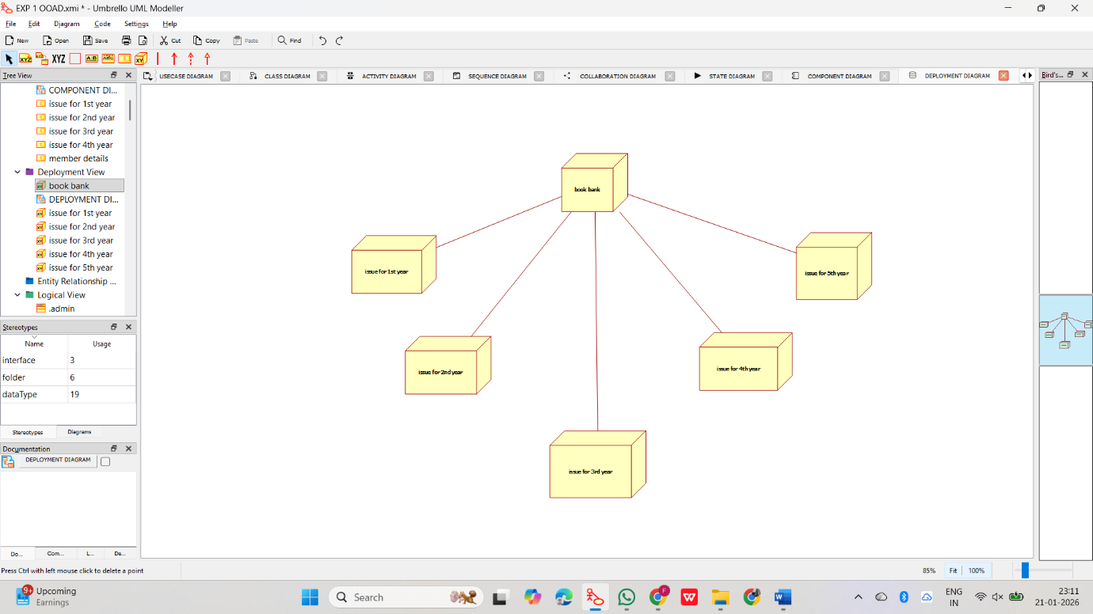

9.PACKAGE DIAGRAMS:
